**SWE645 – HW3: Build survey form using Angular and Spring Boot and setup Kubernetes cluster using Rancher**

**Team Member: Aniket Pandey, Siddhanth Kalyanpur, Tanush Singh**

**Step 1: Write POST and GET api using Spring Tool Suite and connect to SQL**

* Following are the two APIs

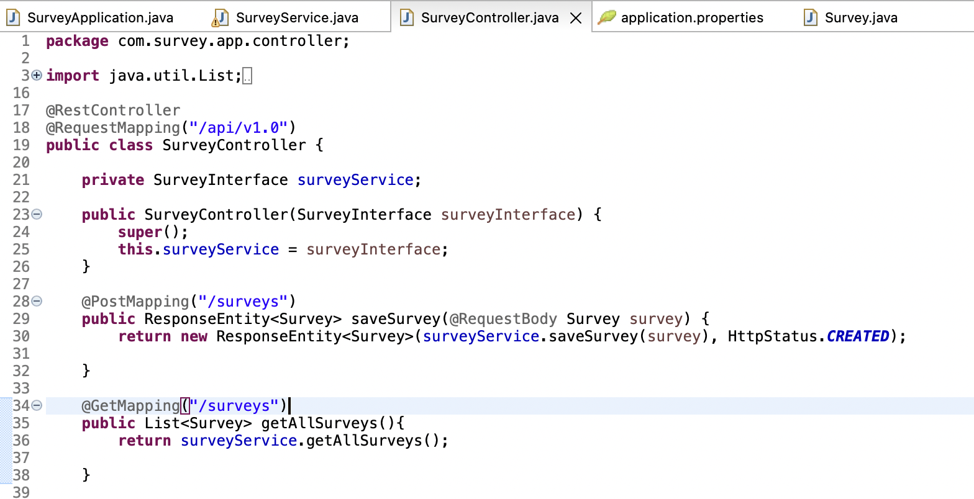

* + GET https://{baseurl}/api/v1.0/surveys
  + POST https://{baseurl}/api/v1.0/surveys

Body

{

"firstName": "John",

"lastName": "Doe",

"email": "john.doe@mail.com",

"address": "9155 Walnut St",

"city": "Bentonville",

"state": "AR",

"zip": "22031",

"telephone": "8188884114",

"dateOfSurvey": "04-28-2022",

"recommendation": "Very Likely",

"interest": "Friends",

"likings": "Students"

}

* The Data Model looks like the following fields

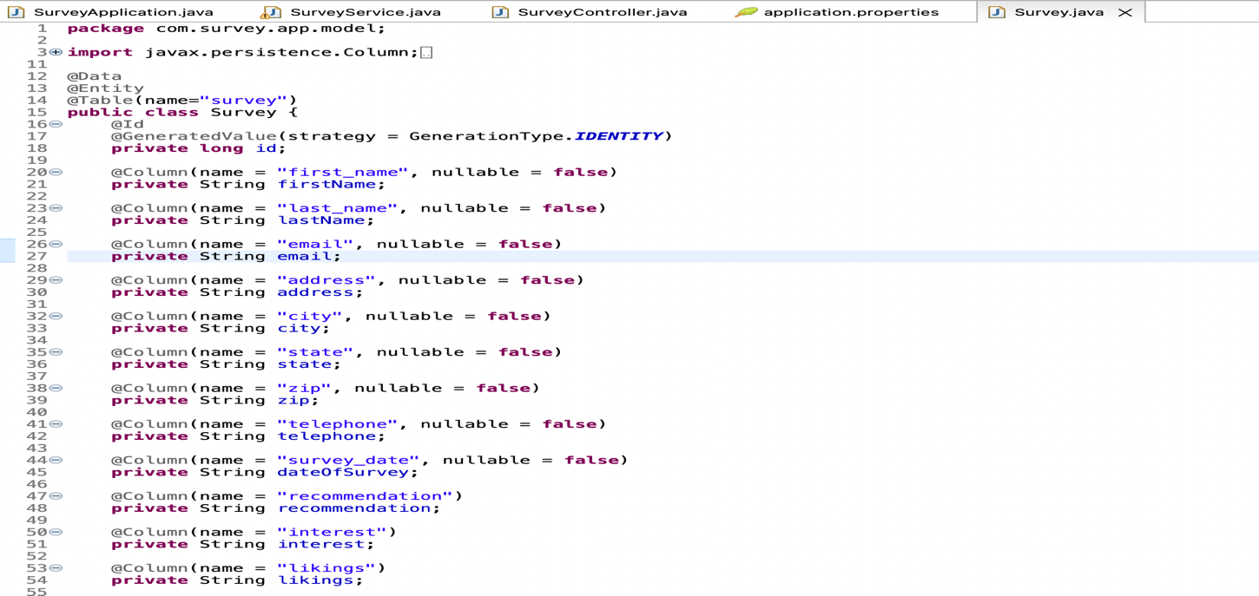

* Write the API and create MySQL database using AWS RDS
* Copy the database endpoint, port number, username and password
* Using JDBC connect to database and write the following lines in application.properties

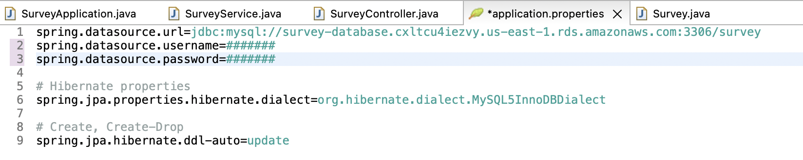

* The api can be tested using Postman
* GET API

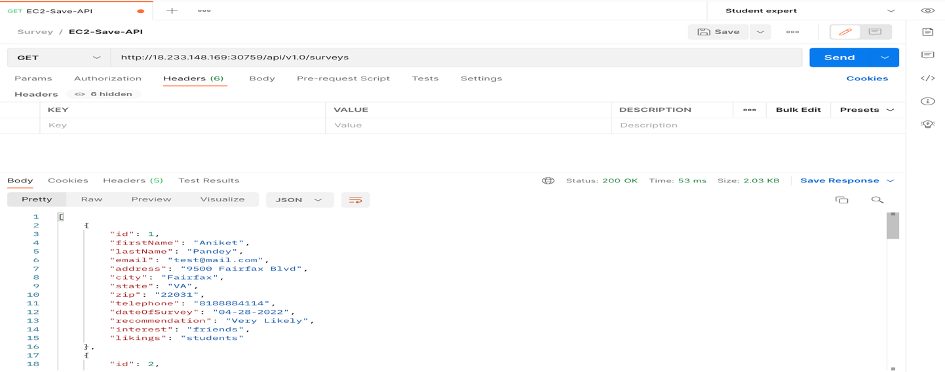

* POST API

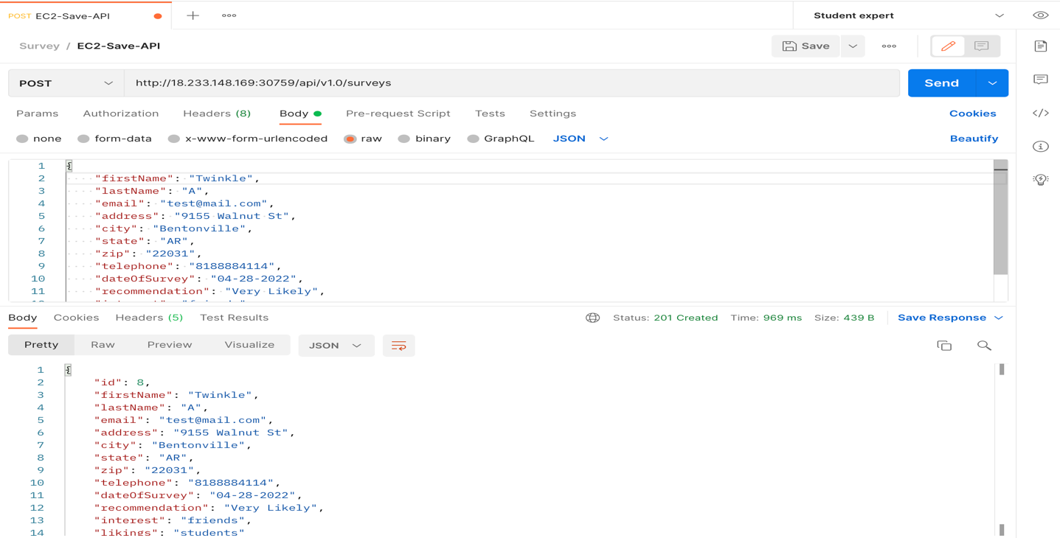

* The Database record can be viewed using MySQLWorkbench

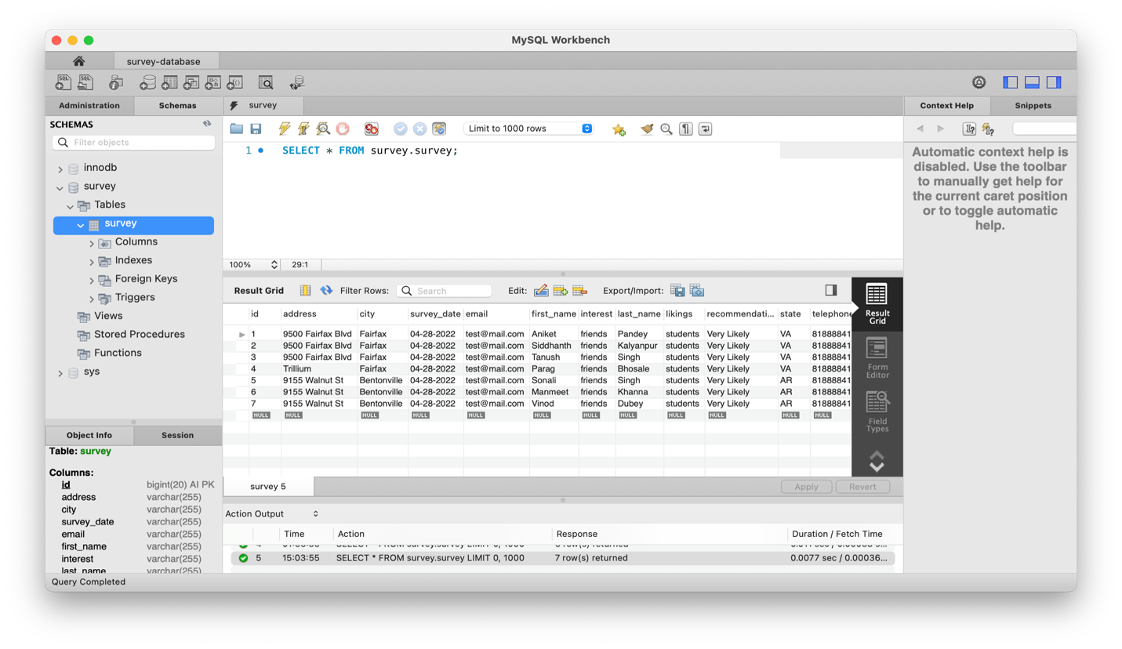

* Now right click on the pom.xml file and build inside the Goal on the next step on build write clean build and the continue with the JAR packaging. The JAR file will be present inside target folder by default.

**Step 2: Build Docker image and containerize survey api using Docker**

* Write Dockerfile as below

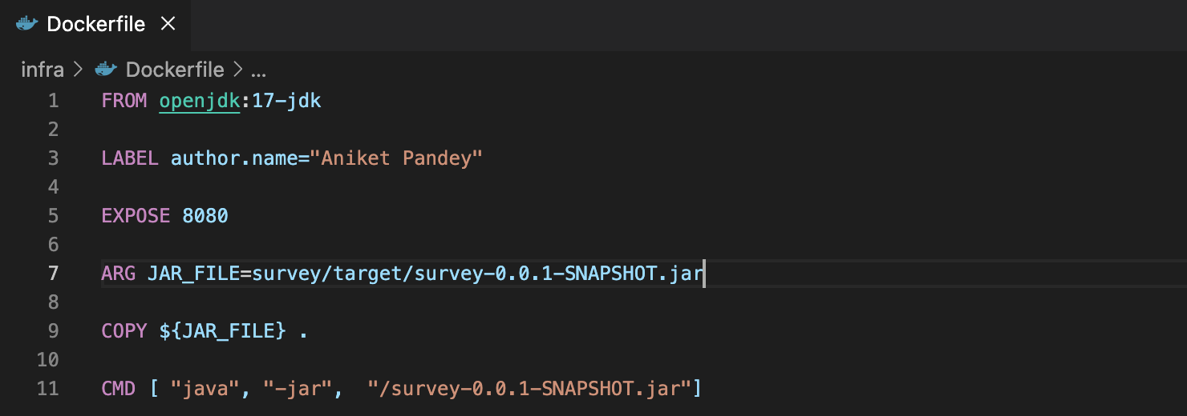

* Build docker image with the below command. My Dockerfile is inside infra folder and therefore I’ve specified path as infra/Dockerfile. As a standard practice all the infrastructure setup related files should be kept inside infra folder for easy segregation.

docker build -f infra/Dockerfile --tag survey-api:amd64-v1.0 .

* Tag the docker image and push it on dockerhub using the below command

docker tag survey-api:amd64-v1.0 aniket414/survey-api:amd64-v1.0

docker push aniket414/survey-api:amd64-v1.0

**Step 3: Create three EC2 instance, two for deployment and the other for Rancher setup**

* Select the Ubuntu ami from AWS marketplace and create one instances for Rancher and select Amazon Linux 2 ami and create instance for deployment of rest api and ui.
* Allow inbound traffic using security group from following ports

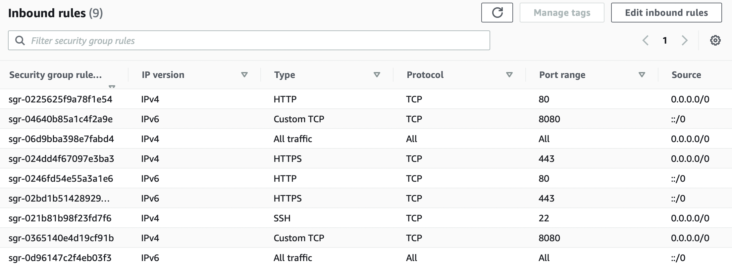

**Step 4: Setup Rancher on one of the instance**

* SSH into the instance using pem file

ssh -i key-value.pem ubuntu@public-dns

* Install docker after updating

sudo apt-get update

sudo apt install docker.io

* Install Rancher using the following command

sudo docker run --privileged -d --restart=unless-stopped -p 80:80 -p 443:443 rancher/rancher

* After some time open instance public dns which will display Rancher login page where we’ll setup username and password
* Login inside and click on create cluster
* Choose custom option from the list of available of available choices and click next
* Enter the cluster name and leave everything as default and click on next
* In the next section select control plane, etcd, and worker and copy the command generated

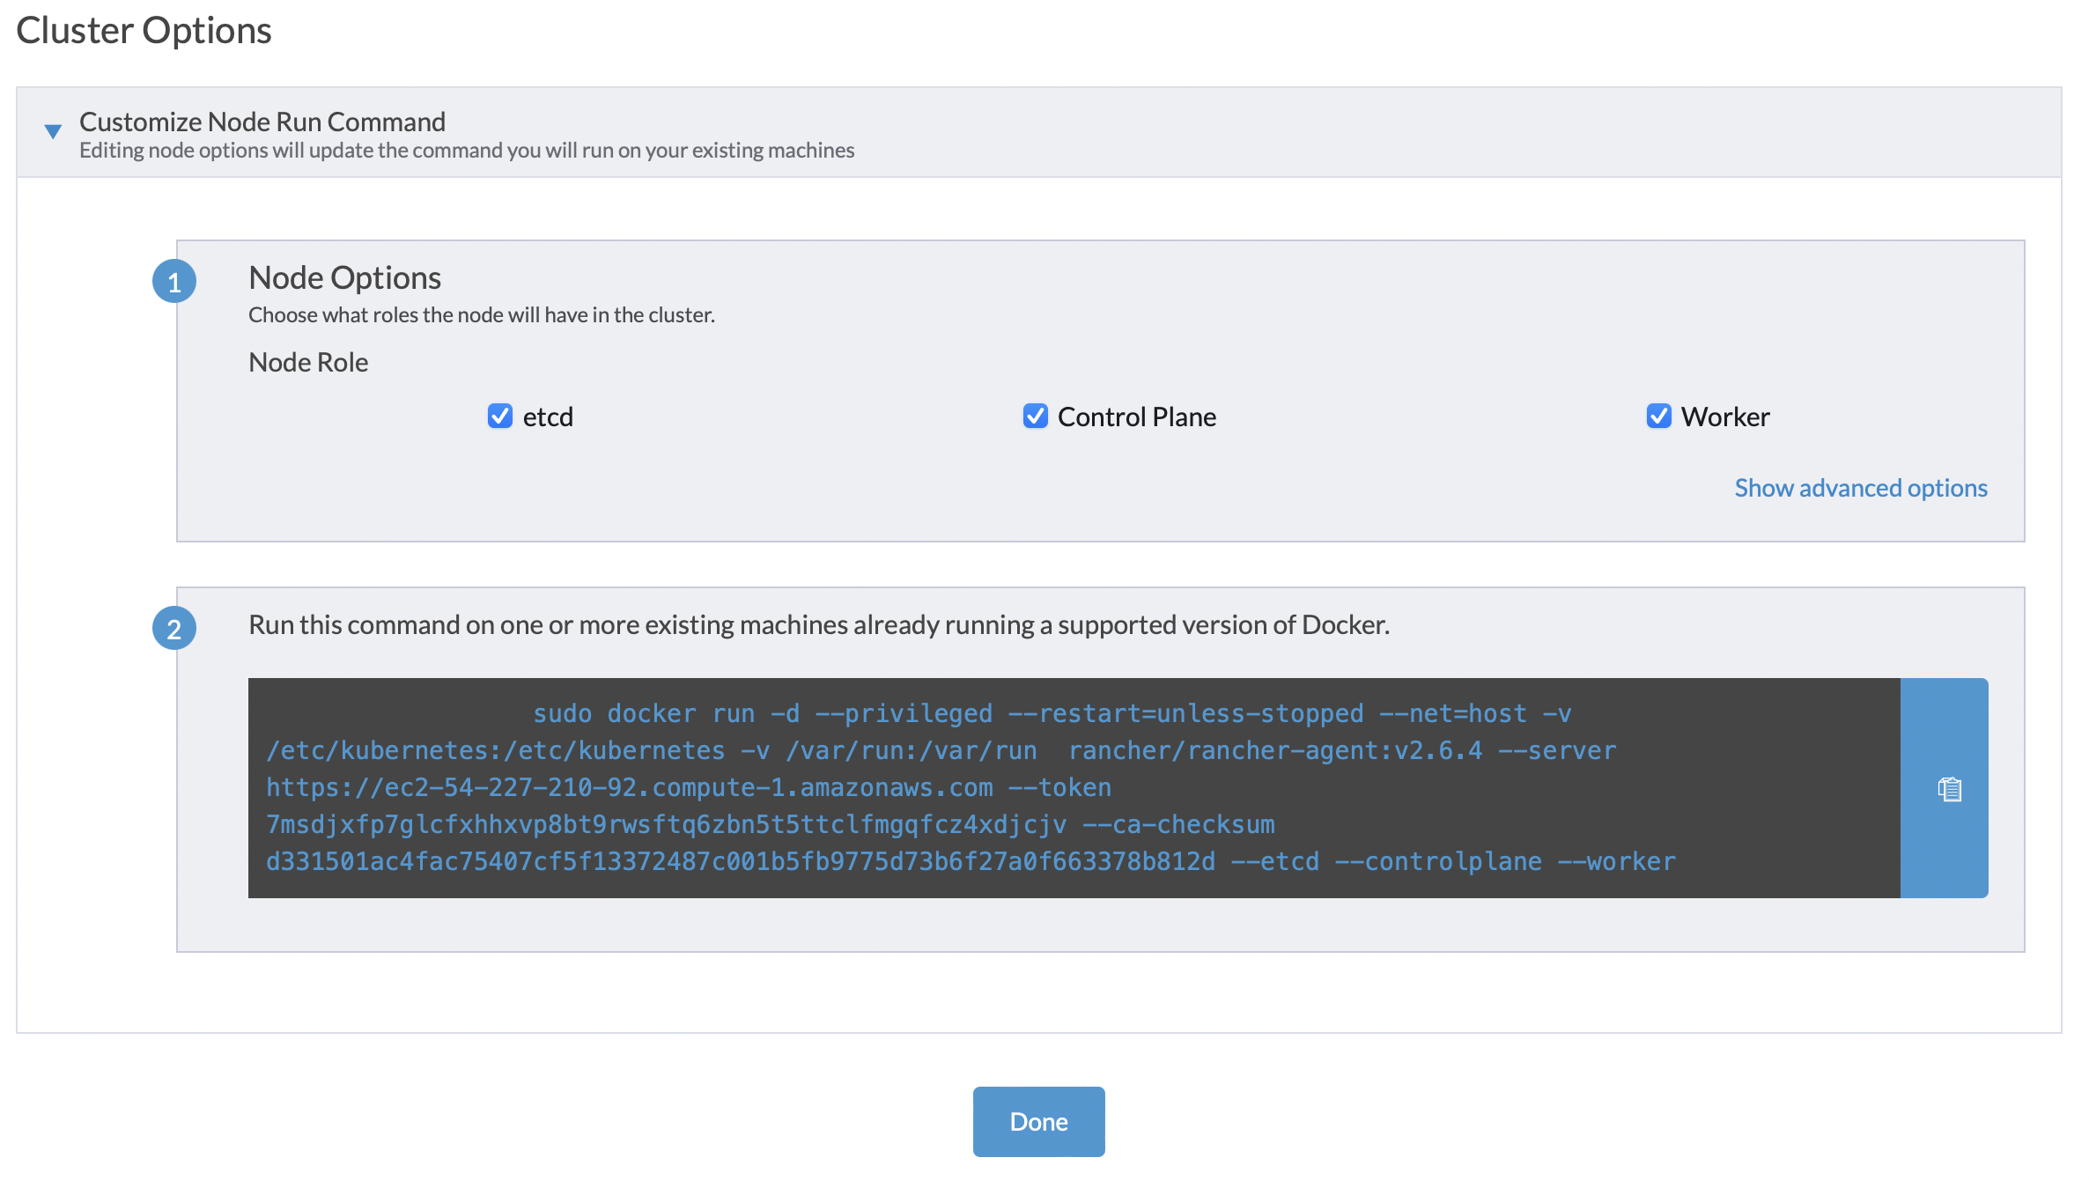

**Step 5: Setting up another instance for api orchestration**

* SSH into the instance using pem file

ssh -i key-value.pem ec2-user@public-dns

* Install docker after updating

sudo yum update

sudo yum install docker

sudo service docker start

* Run the above copied command and after some time go to the Rancher page and you should see cluster provisioning has started.

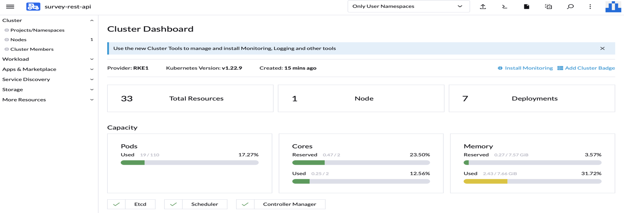

* Condition of the cluster is active and healthy

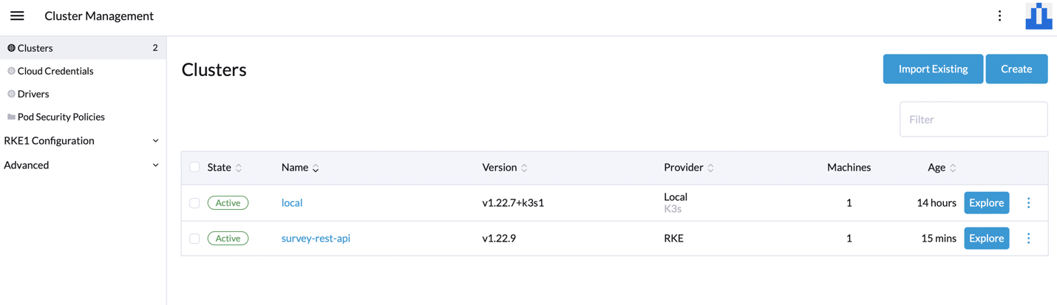

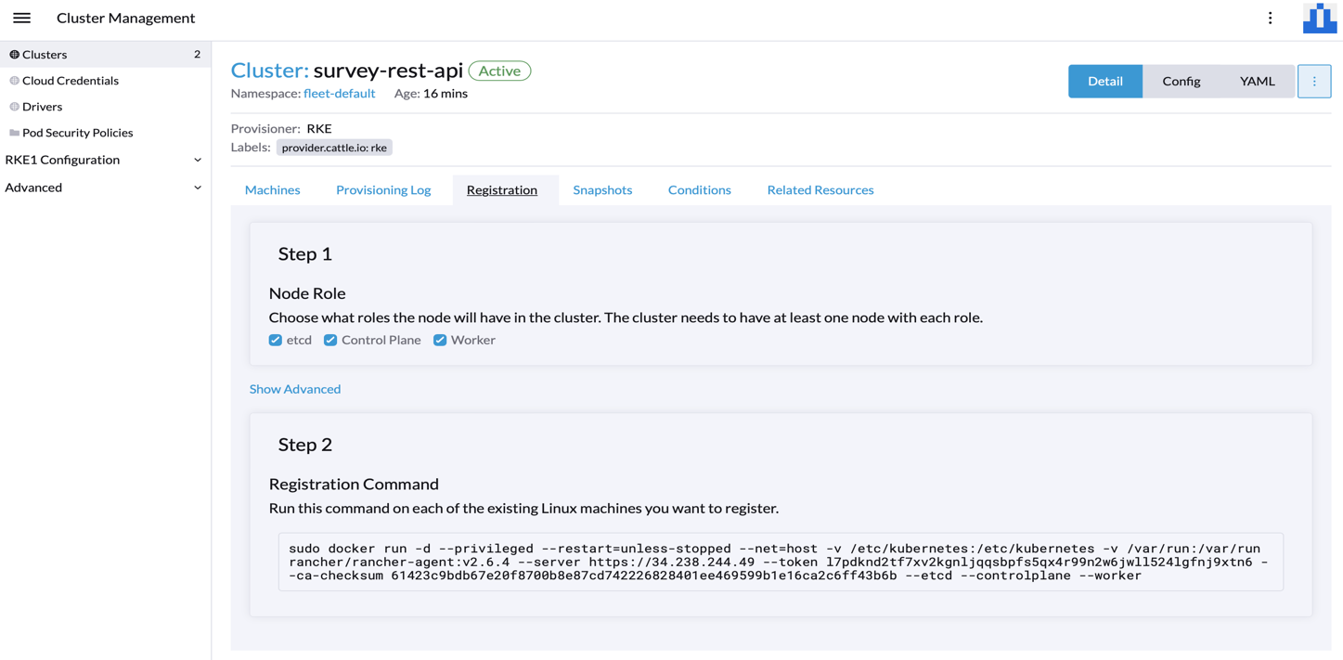

**Step 6: Deploy the survey-api docker image on cluster on setup three pods running at all time**

* Enter the cluster just created on Rancher and click on Deployment under the Workload section. Alternatively you can also copy the kubeconfig file and if you have kubectl setup done on your local then paste the kubeconfig file content in .kube/config and you can easily access the cluster and deployment using kubectl from your local.
* Enter the replica set as mentioned in assignment i.e. 3
* Enter the docker image uri
* Setup NodePort as a service

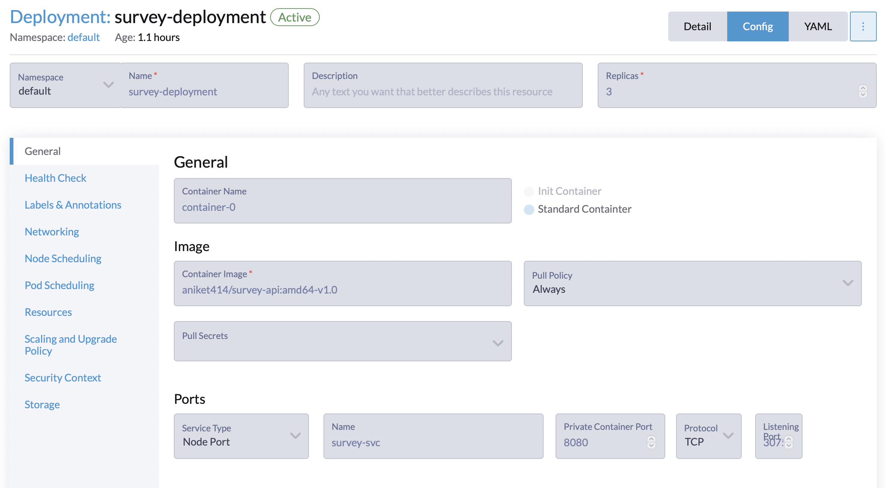

* Click on done and you should see your pods coming up.

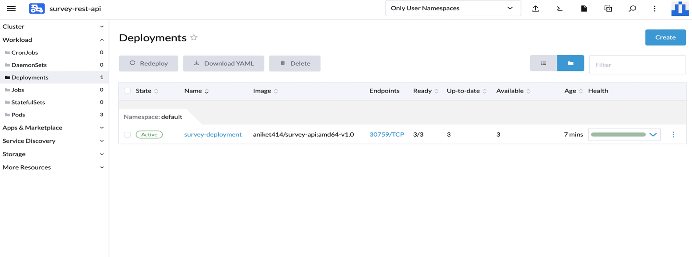

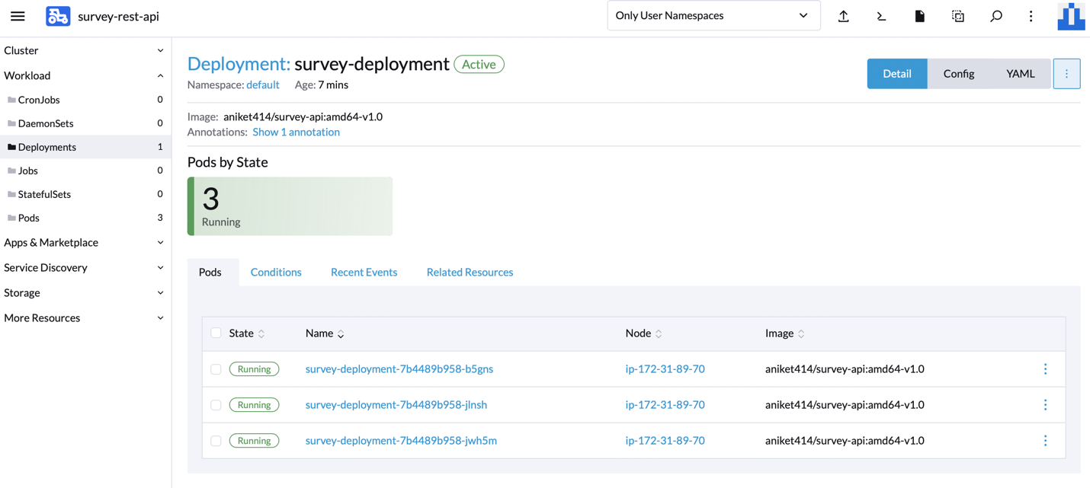

* You can also verify the status from local using kubectl command
* Following are the screenshot of service, node, deployment, and pods

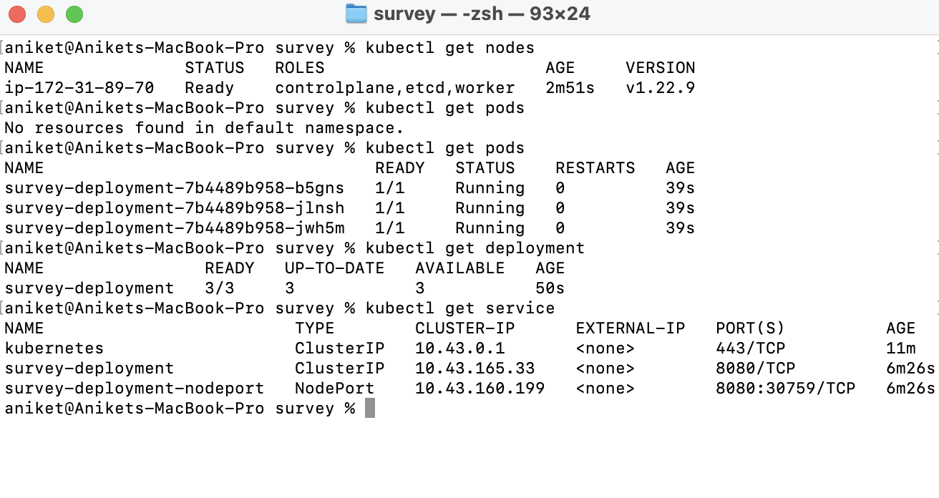

**Step 7: Create Angular application**

* Create a service call and make GET and POST calls to the api using HttpClient
* The url should be the url of the EC2 instance on which the api is deployed. Check the image below with baseUrl.

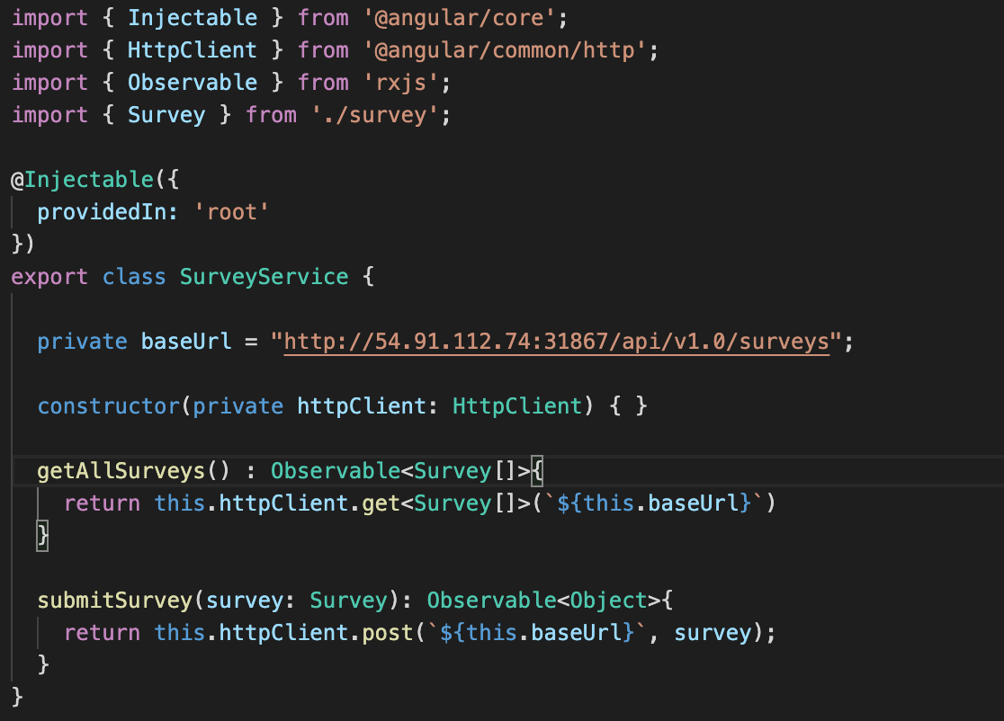

* Following is the walk through of Angular project

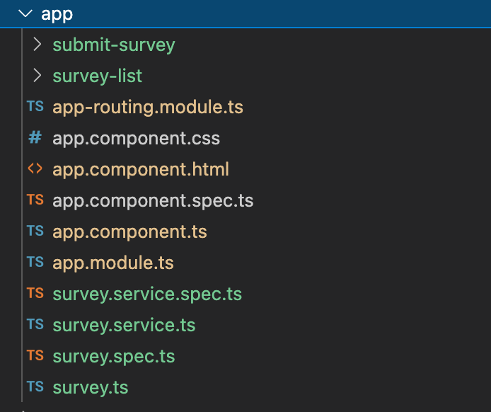

* + Class for data binding: survey.ts
  + Service for API calls: survey.service.ts
  + Submit form component: submit-survey
  + Get list of all the surveys: survey-list

**Step 8: Build Docker image and containerize survey ui using Docker**

* Write Dockerfile as below

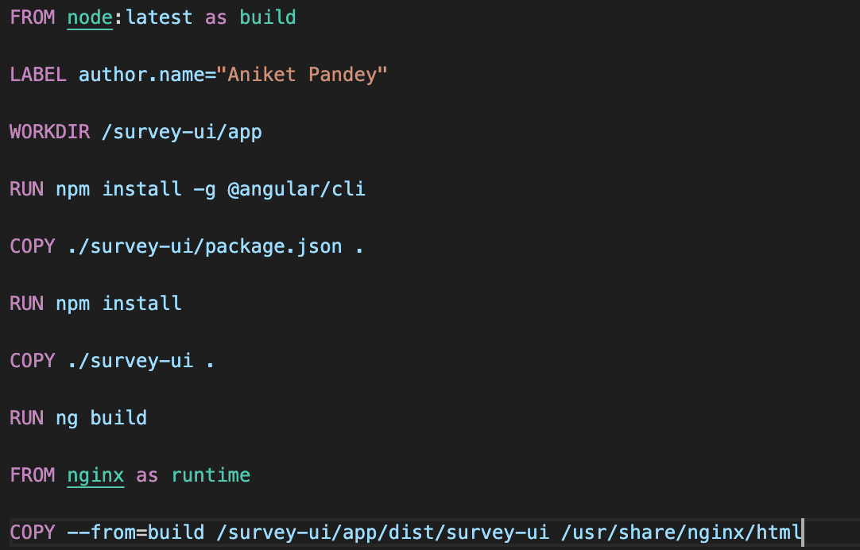

* Build docker image with the below command. My Dockerfile is inside infra folder and therefore I’ve specified path as infra/ui.Dockerfile. As a standard practice all the infrastructure setup related files should be kept inside infra folder for easy segregation.

docker build -f infra/ui.Dockerfile --tag survey-ui:amd64-v1.0 .

* Tag the docker image and push it on dockerhub using the below command

docker tag survey-ui:amd64-v1.0 aniket414/survey-ui:amd64-v1.0

docker push aniket414/survey-ui:amd64-v1.0

**Step 9: Deploy the survey-ui docker image on cluster on setup three pods running at all time**

* Now similarly perform Step 5 and Step 6 as mentioned above for Angular UI deployment.

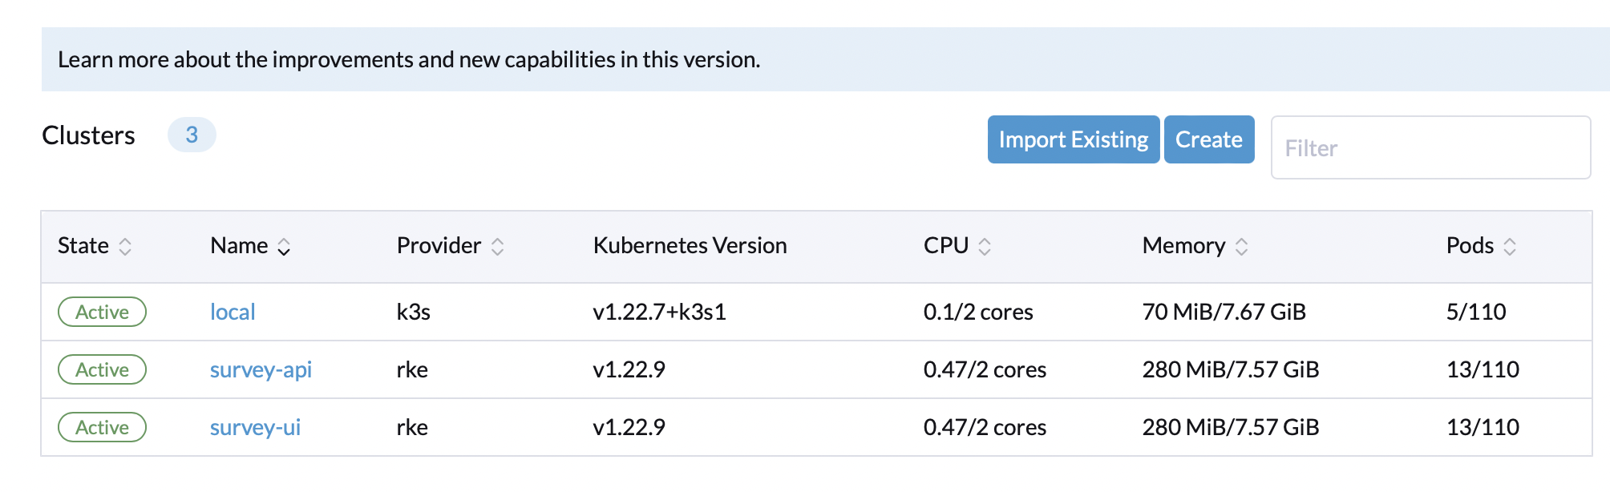

* The cluster for UI is setup above
* The deployment of 3 pods is done and can be seen as below which are in ready state.

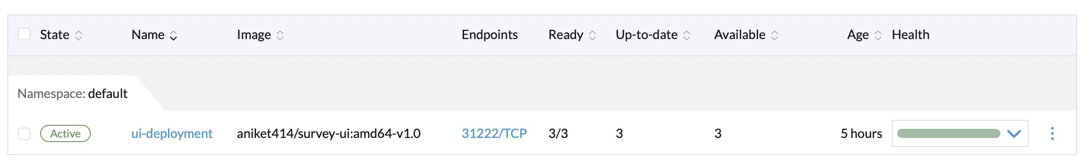

* After deployment the UI will look like as below



* This is the homepage it has two navigation options one to view list of surveys done till date and the other is for submitting new survey

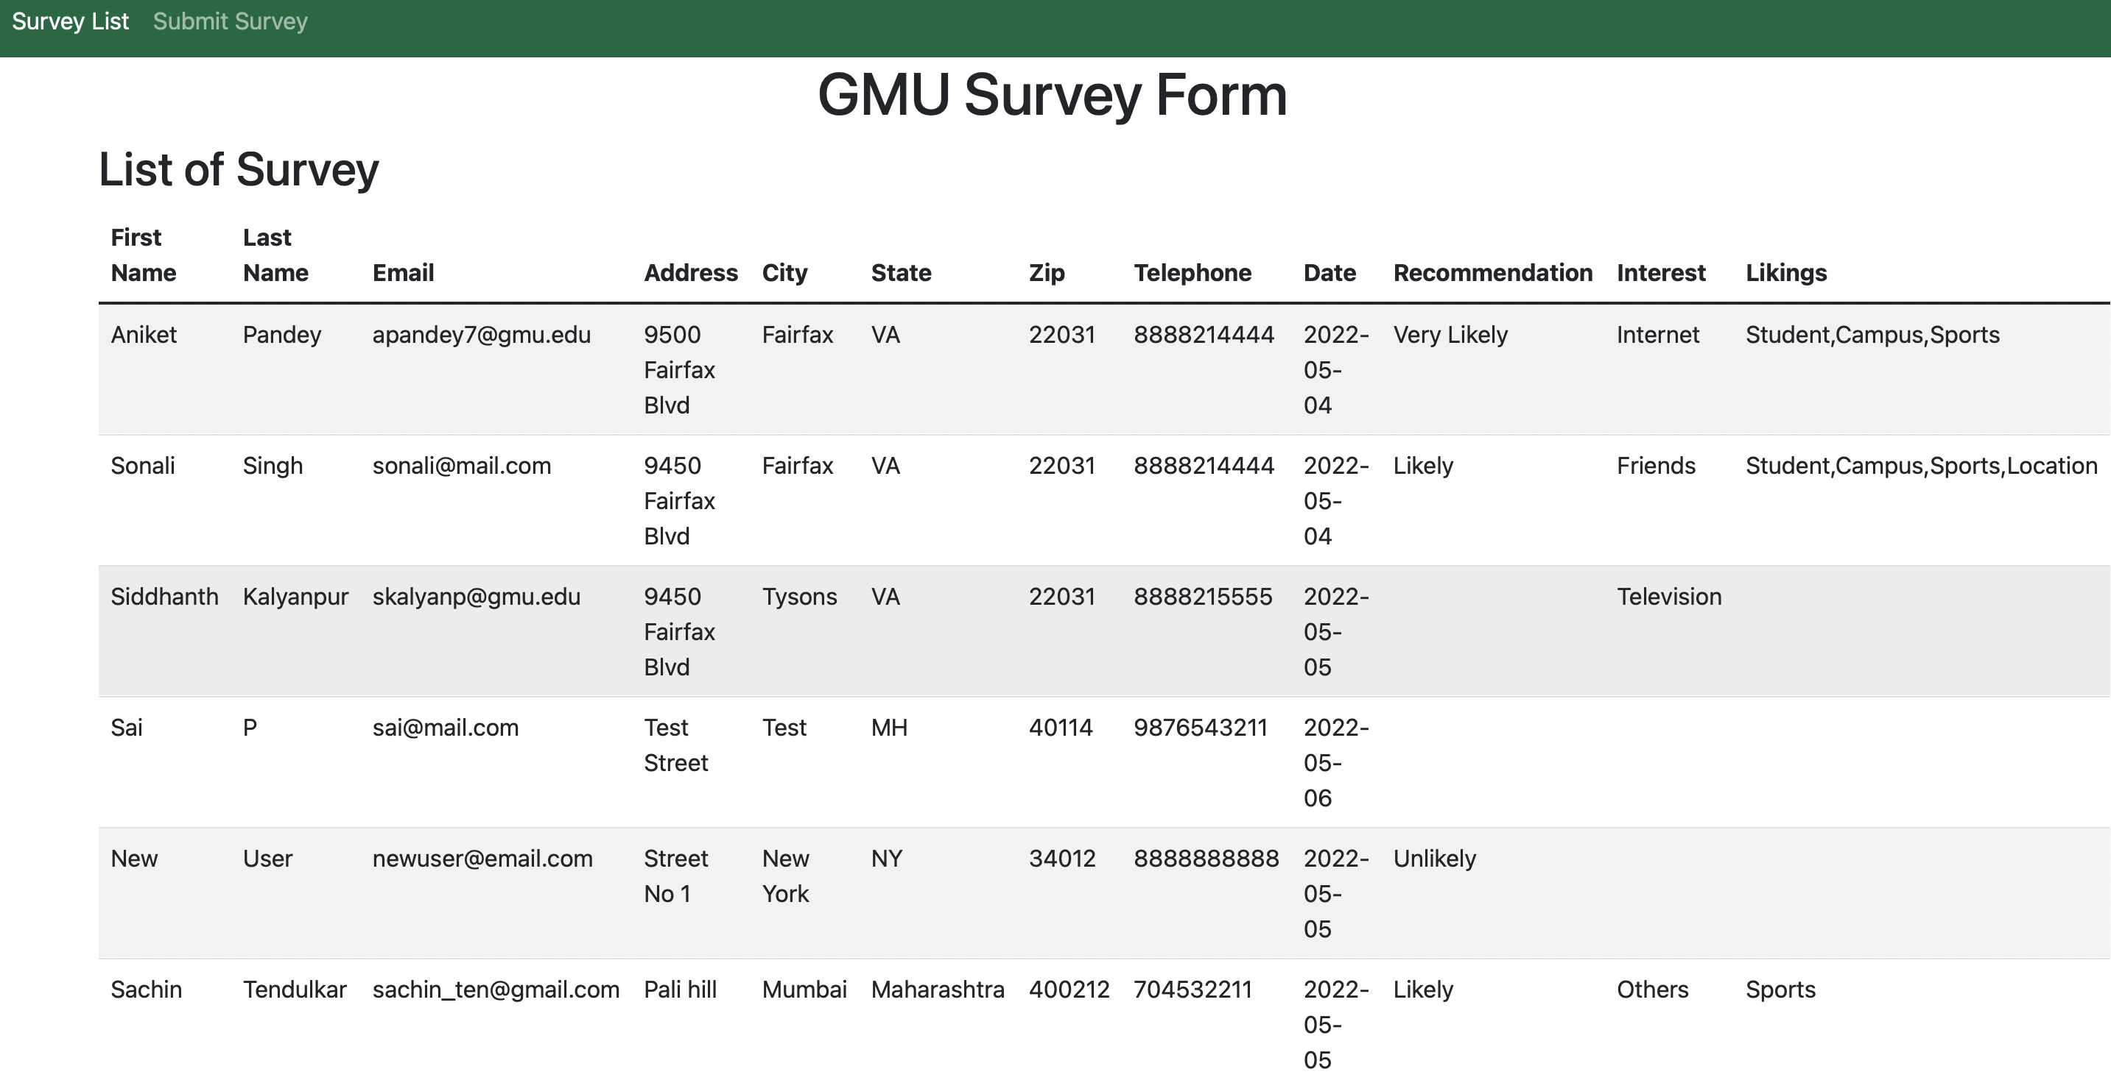

* The above image displays list of surveys

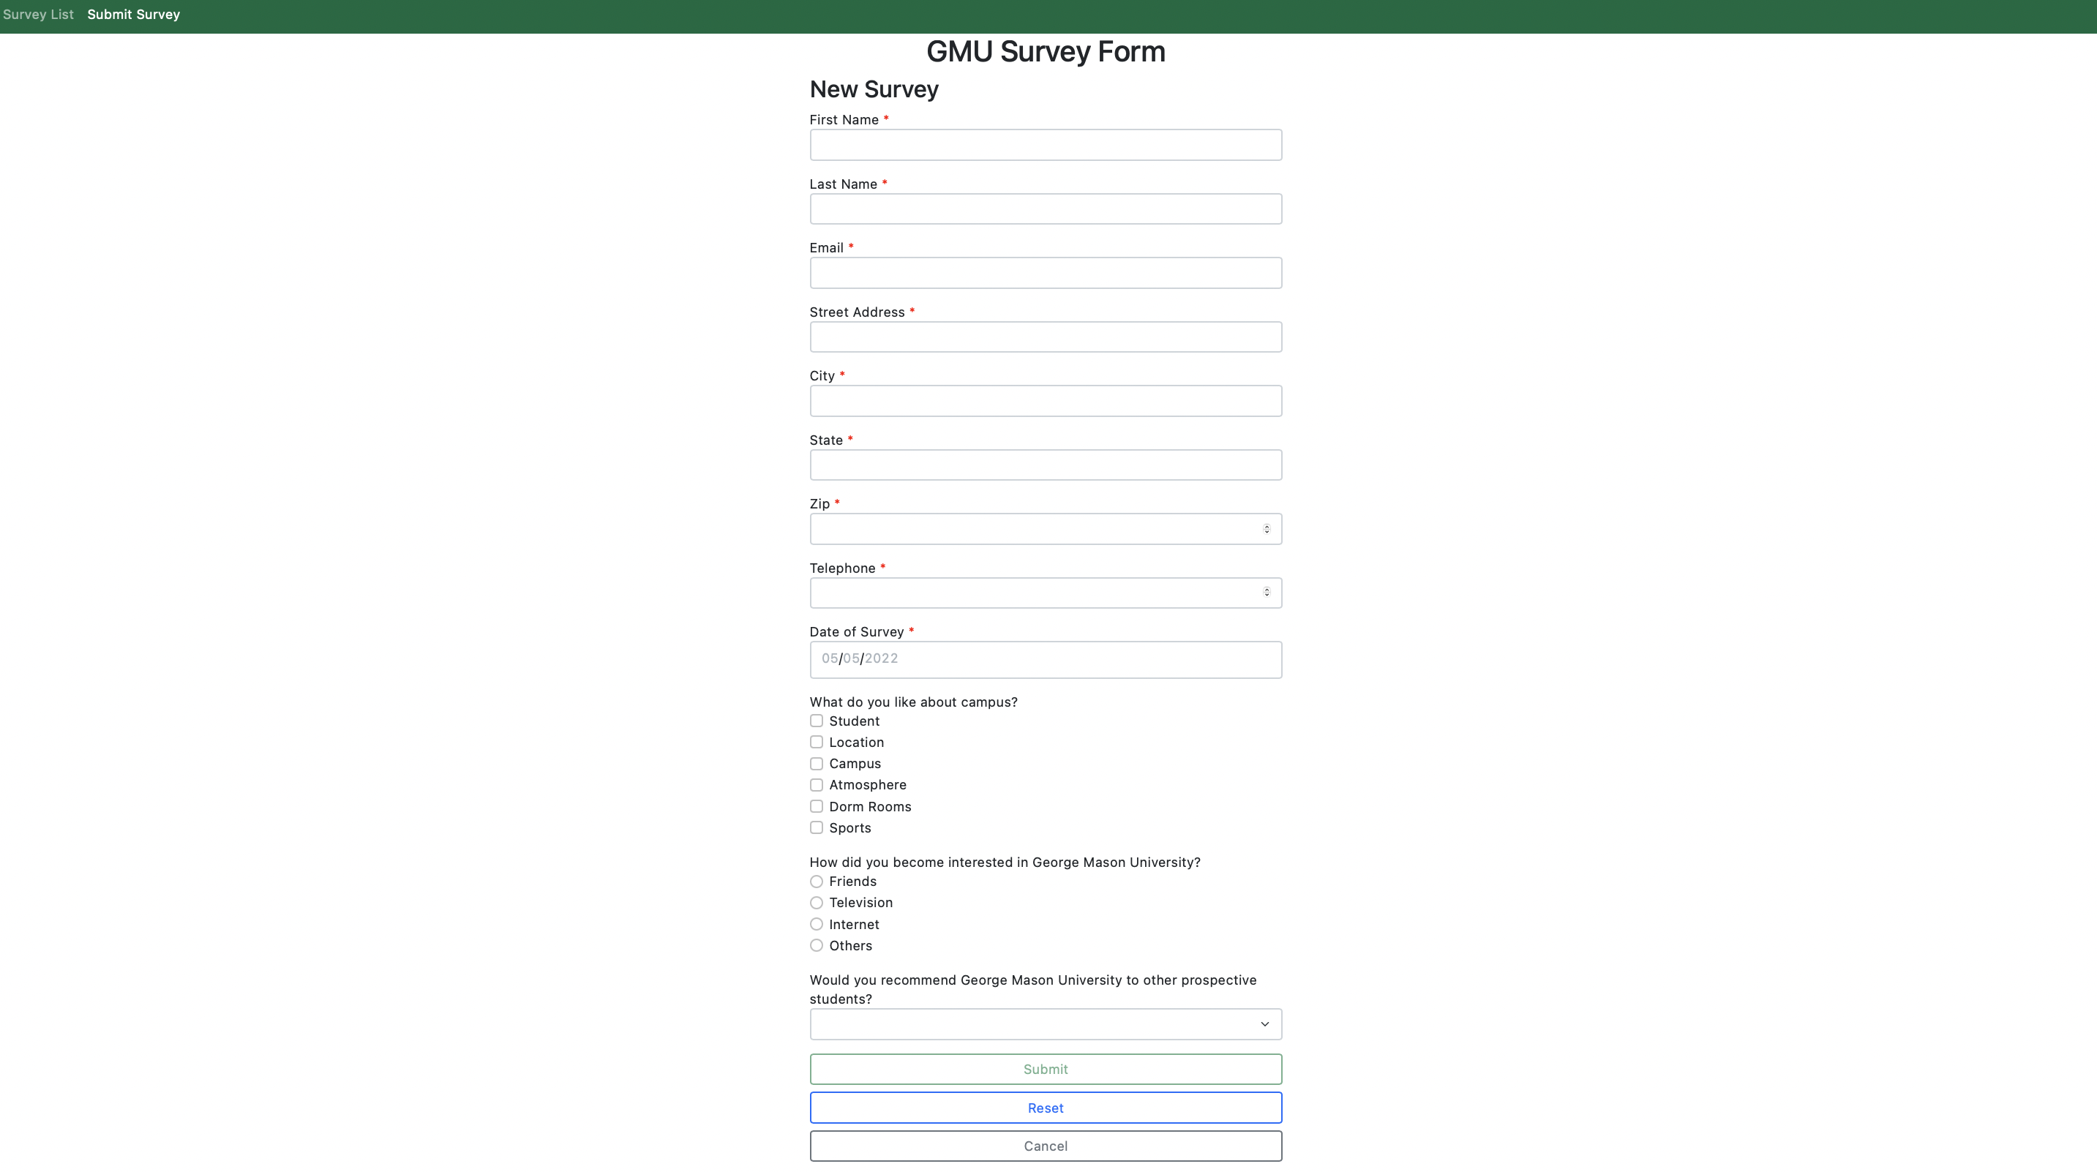

* The above image displays the survey form with all the fields.
* The UI calls the API can also be verified from the browser inspect.

